Write a MATLAB program to find laplace transform of the following signals

a) t

b) e^(-at)

c) te^(-at)

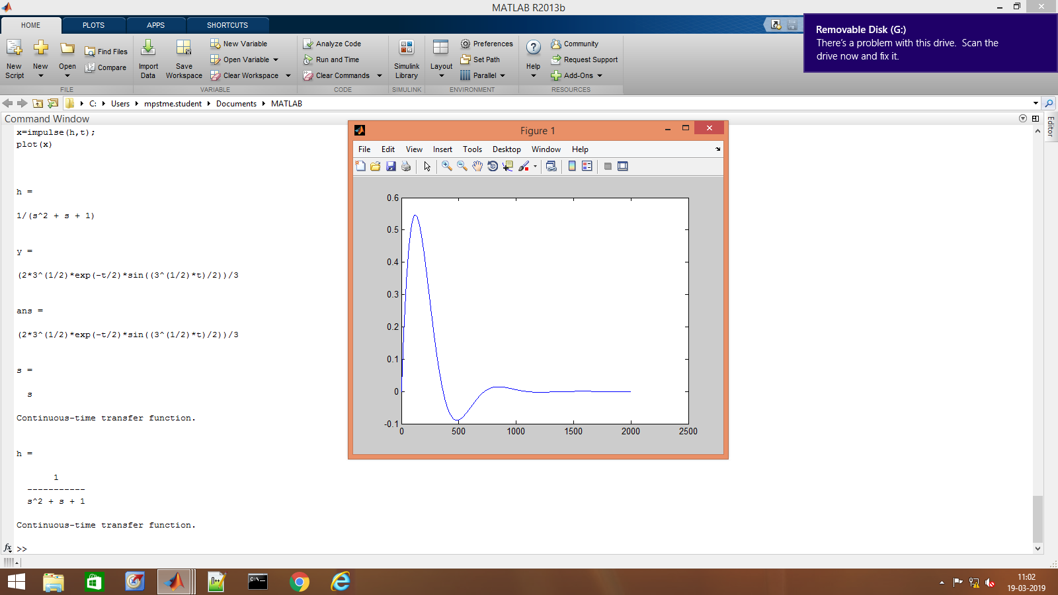

%(1)

syms t real;

syms s complex;

syms a real;

f=t

laplace(f)

disp (1)

%(2)

f=exp(-a\*t)

disp(2)

laplace(f)

%(3)

f=t\*exp(-a\*t)

disp(3)

laplace(f)